**EXPERIMENT 10: Demonstrate version control in Git and Github.**

Source Code:

$ git config --global user.name "cmr"

$ git config --global user.email [cmr@example.com](mailto:cmr@example.com)

Index.html

<h1>welcome to my web page</h1>

git init

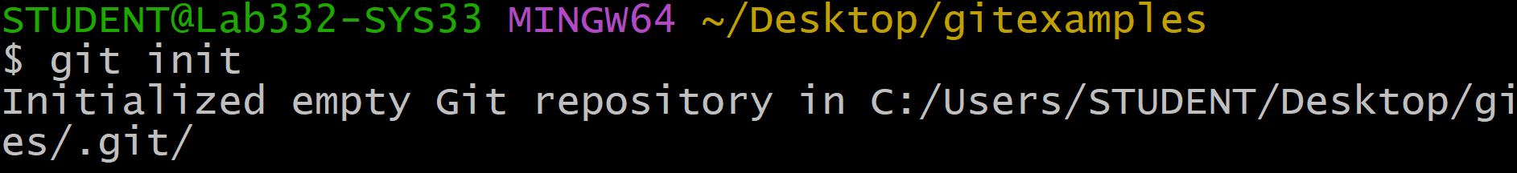

git add .

git commit -m "Hello world"

Create a new file (Index.html)

<h1>welcome to my web page</h1>

<p>My first website</p>

git add .

git commit -m "paragraph added"

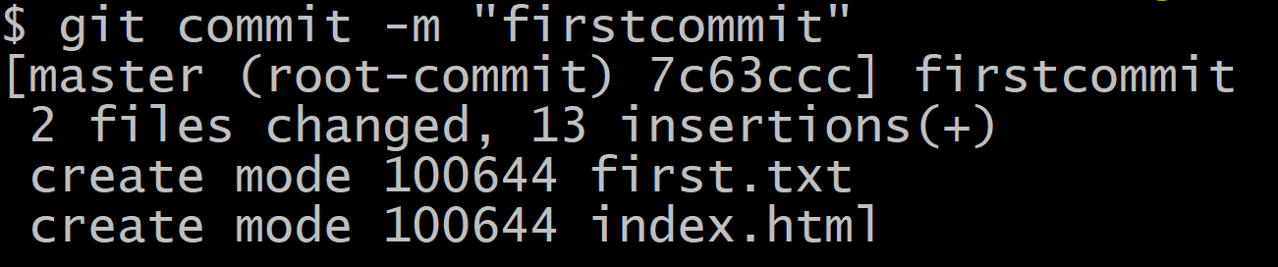

git log

git status

git branch -M main

git remote add origin url

git push origin main --force

